Practical No: 9

**Aim:** Visitor Monitoring with Raspberry Pi and Pi Camera.

**Hardware Required:**

1. Raspberry Pi 3B+
2. Ethernet Cable
3. Monitor
4. HDMI to VGI convertor
5. Micro SD card (any class best is class 10)
6. Adaptor with 5v 2A
7. USB mouse
8. USB keyboard
9. Pi Camera

**Software Required:**

1. VlC media player

**Procedure:**

1. **Hardware Setup:**

* Connect the Pi Camera to the camera port in the Raspberry pi. 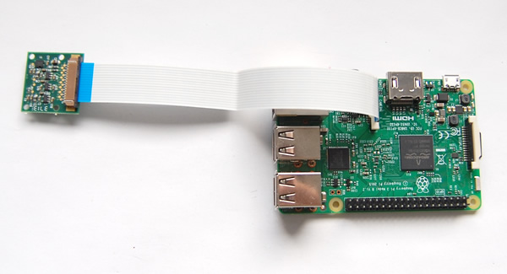

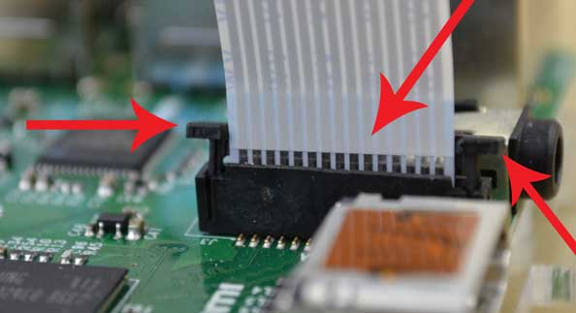

1. **Software Setup:**

* Start🡺 Preferences 🡺 Raspberry Pi Configuration 🡺 Interfaces 🡺Enable Camera.
* Install VLC in Raspberry pi by typing the following code in the terminal.
* sudo apt install vlc
* ifconfig (jot down the IP address of the raspberry Pi)
* raspivid -o - -t 0 -n -w 600 -h 400 -fps 12 | cvlc -vvv stream:///dev/stdin --sout '#rtp{sdp=rtsp://:8554/}' :demux=h264
* Install VLC In Desktop PC (<https://www.videolan.org/vlc/download-windows.html>)
* Open VLC Media Player Media 🡺Open Network Stream 🡺 type the following address in to the URL ( rtsp://**<Your_IP_ADDRESS>:**8554/ ) use the jotted IP address.